MMBasic for ELLO 2M and
ELLO 2M² computers

Addendum
to
Micromite MMBasic (original document)
Micromite PLUS Addendum (original document)

MMBasic is a powerful implementation of the BASIC language with full floating point support, string variables, long variable names, multi-dimensional arrays, graphics, low-level driver support, and many more features.

The ELLO 2M and ELLO 2M² computers use MMBasic for Micromite Plus, and also contain some additions and improvements, some of which in the form of extra commands and functions, but the majority of them invisible to the end user. These additions allow more effective utilisation of the hardware capabilities of ELLO 2M and ELLO 2M².

This manual describes only the additions and changes introduced for the support of the ELLO 2M and ELLO 2M² computers. It does not replace the original MMBasic manual but only completes it with the additional information.

ELLO 2M and ELLO 2M² computers are designed and manufactured by Yellow Beak Computer, Ltd. © 2015-2017
This manual is licensed under CC BY-NC-SA 3.0

ELLO 2M Keyboard

ELLO 2M and ELLO 2M² are built as standalone computing systems with own keyboard and display. The keyboard layout is a mix of the standard US and UK keyboards with some new touch for more universality.

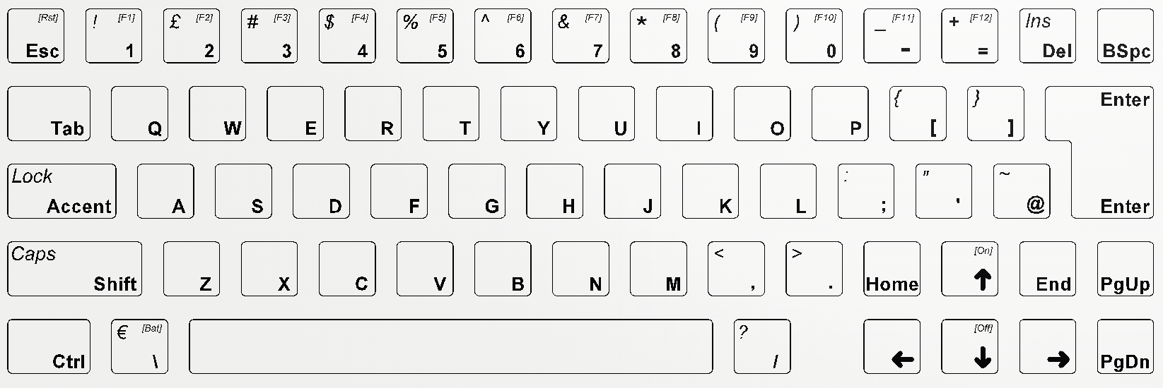

Some keys have small texts enclosed in square brackets, such as [F1], [Rst], etc.
These functions are accessible by pressing and holding the key “Ctrl” while pressing the key with the indicated function.

Four of the keys with text in square brackets require additional explaining:
- The key [On] is to switch the system on by holding “Ctrl” and [On] for about two seconds.
- The key [Off] switches the system off. It requires holding for about 4 seconds.
- The key [Rst] performs system reset after about 3 seconds.
- The key [Bat] is reserved for battery testing functionality in future.

An obvious difference is the “Accent” key which has replaced the traditional “Caps Lock”. It works exactly like the “Shift” key, and its function is to enable easy access to all characters from the extended part of the ASCII table. When pressed and held, and another key is pressed, it will produce a character from the extended codes of the table. The most used ones are the language accent characters such as “ë” or “ç”, hence the name of the key.

Keyboard layout in accent mode
¹ ² ³ ⁴ ê ß ì ª í ø ― ¬

à á ë è ù ý ü ï ö þ æ œ

ä š ð é û ú î ó ô ÿ µ ©

ž ã ç å õ ñ ò ° • † ▓ ‡ ¦

â ÷ ░ ▒ ƒ ‰

Keyboard layout in Shift-Accent mode
¡ ¥ § ¢ Ê º Ì × Í Ø ¯ ±

À Á Ë È Ù Ý Ü Ï Ö Þ Æ Œ

Ä Š Ð É Û Ú Î Ó Ô Ÿ ¶ ®

Ž Ã Ç Å Õ Ñ Ò « » † ▓ ‡ ¦

Â ¿ ░ ▒ ƒ ‰

When the “Accent” key is double-pressed (quickly pressed twice), it enters in “Accent Lock” mode where the keyboard produces accented characters without the need to hold “Accent” continuously. Another double press cancels the mode.

The Shift character operates in the same manner – a double press of the “Shift” key is equivalent of “Caps Lock” activated.

Both “Accent” and “Shift” keys are independent and can be independently locked and unlocked – for example to continuously produce capital accented characters.

The current mode is displayed by changing the colour of the light indicator “ST”
- Normal operation mode (no lock to “Accent” or “Shift”): blue
- “Caps Lock” mode: white
- “Accent Lock” mode: yellow
- “Accent Caps Lock” mode: red

Another difference is the lack of “Insert” key. It is now moved to the “Del” key in shift mode.

Program and Data Storage

Up to five MMBasic “drives” are available for storing and loading programs and data:

- Drive “A:” (only available in ELLO 2M²) a virtual drive using part of the internal flash memory and has size of about 800k. It can be used as general data and program storage as well as it is the default place where the help information is stored as a separate system file.
- Drives “B:”, “C:”, “D:”, and “E:” are supported in the system. With the exception of the last one, the first three hard SD card connectors installed on the PCB1 board. Supported are MMC, SD or SDHC memory cards formatted as FAT16 or FAT32 with capacities up to 64 Gigabytes.

File names must be in 8.3 format (8 characters for file name and 3 characters for extension), prefixed with an optional drive prefix A: or B: (the same as DOS or Windows). Long file names and directories are not supported. The default drive after power on and reset events is B: and it can be changed with the command DRIVE.

During start up drive B: will be selected as default. A new drive can be selected by using the DRIVE command. For example DRIVE “C” will select drive C: as default. Once a drive has been selected, all file commands and functions will refer to files and data on that drive, until a new drive is selected by another DRIVE command.

Drive A: does not support hierarchic organisation with folders. All files in A: only exist in the root folder. However a file in A: can be made “hidden” if its name starts with the “.” character. For example the file MYPROG.BAS in A: is a normally visible file, while the file .MYPROG.BAS will not be seen in the FILES command. Making files in A: hidden can be used to protect important system files from being inadvertently deleted or corrupted in other way by the user.

When connected to a PC via USB, the A: drive appears as accessible data storage drive on the computer. This feature is always available and does not require any user interaction. In some cases that might be undesired and can be permanently disabled with command OPTION MSD OFF. If needed it can be enabled again with the command OPTION MSD ON.

Full 8-bit ASCII support

The ELLO 2M and ELLO 2M² version of MMBasic supports the full 8-bit character table according to ISO-8859-15. Additional characters have been assigned to the unused codes as well. The full table is shown below.
A full 224-character 10x20 pixel font is also built-in as font #97. It is the default console font.

Character table in ELLO 2M and ELLO 2M²

hex | 00 | 01 | 02 | 03 | 04 | 05 | 06 | 07 | 08 | 09 | 0A | 0B | 0C | 0D | 0E | 0F
00 | NON-PRINTABLE CODES
10
20 |  | ! | “ | # | $ | % | & | ‘ | ( | ) | * | + | , | - | . | /
30 | 0 | 1 | 2 | 3 | 4 | 5 | 6 | 7 | 8 | 9 | : | ; | < | = | > | ?
40 | @ | A | B | C | D | E | F | G | H | I | J | K | L | M | N | O
50 | P | Q | R | S | T | U | V | W | X | Y | Z | [ | \ | ] | ^ | _
60 | ` | a | b | c | d | e | f | g | h | i | j | k | l | m | n | o
70 | p | q | r | s | t | u | v | w | x | y | z | { | | | } | ~
80 | ░ | ▒ | ▓ | ƒ | √ | … | † | ‡ | ¦ | ‰ | ≤ | ← | ↑ | ≈ | π | Ω
90 | ∞ | ─ | ⁴ | ∫ | ¤ | │ | ½ | ¼ | ¾ | ™ | ≥ | → | ↓ | ∆ | ∏ | ∑
A0 |  | ¡ | ¢ | £ | € | ¥ | Š | § | š | © | ª | « | ¬ | ― | ® | ¯
B0 | ° | ± | ² | ³ | Ž | µ | ¶ | • | ž | ¹ | º | » | Œ | œ | Ÿ | ¿
C0 | À | Á | Â | Ã | Ä | Å | Æ | Ç | È | É | Ê | Ë | Ì | Í | Î | Ï
D0 | Ð | Ñ | Ò | Ó | Ô | Õ | Ö | × | Ø | Ù | Ú | Û | Ü | Ý | Þ | ß
E0 | à | á | â | ã | ä | å | æ | ç | è | é | ê | ë | ì | í | î | ï
F0 | ð | ñ | ò | ó | ô | õ | ö | ÷ | ø | ù | ú | û | ü | ý | þ | ÿ

IMPORTANT: A string that starts with an extended character (i.e. with ASCII code greater than 127), must be preceded by two double quotes.

Example: ""µmite"

This rule is required only if the first character of the string is an extended code.

Expansion Connector

ELLO 2M and ELLO 2M² computers have expansion connector with pinout as shown in the pictures below. The connector is a standard 36-pin female square pin receptacle with 2.54mm (0.1”) pitch. It can be used to connect various expansion boards or prototype jumper wires.

ELLO 2M expansion connector

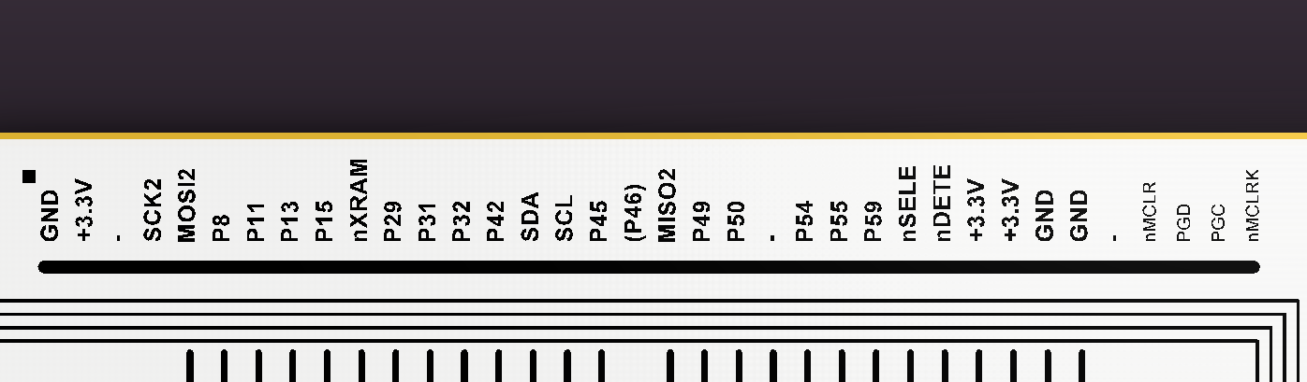

ELLO 2M² expansion connector

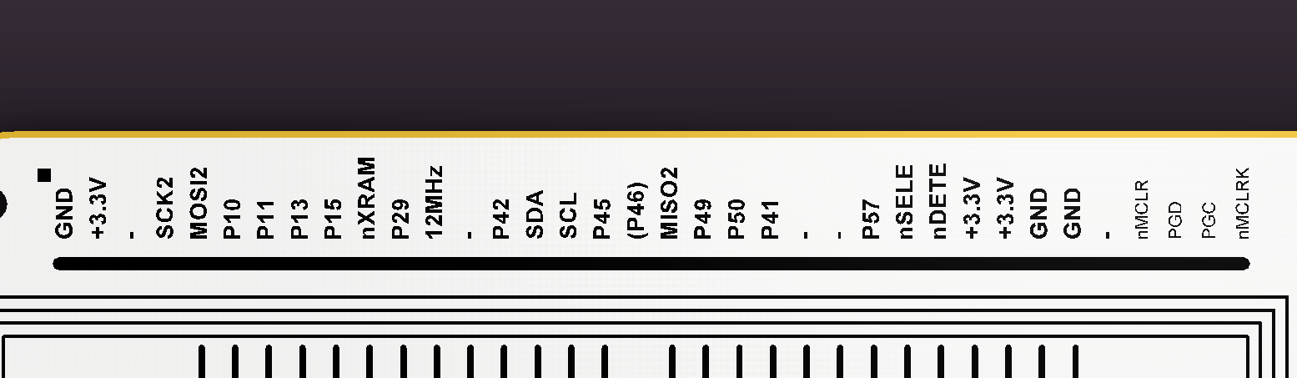

Firmware Updates

MMBasic on ELLO 2M and ELLO 2M² can update itself with a newer version of the firmware to include new features or fix previously known problems.

The command to activate this functionality is FWUPDATE. It must be executed in direct mode with the system attached to a PCB via USB cable.

Select the button “Open HEX File”. A file selection dialog will appear. Choose the file with the new firmware.

Press “Program/Verify” and wait until the process is complete.

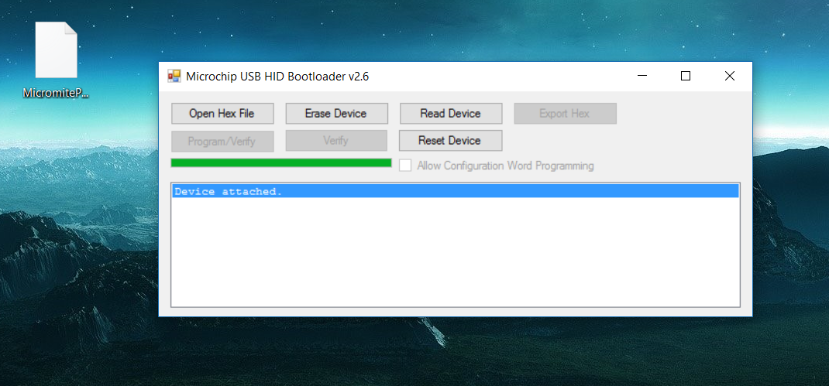

If due to some unfortunate event the update gets interrupted before completion (USB cable pulled out, for example), MMBasic will not be available anymore. There is a more “hardware-type” way to restore the firmware even from that situation.
Switch the system off, connect a jumper wire between the pins marked as “PGD” and “GND” on the expansion connector, and switch the system again. It will be forced back in bootloader mode.

Now remove the jumper cable (IMPORTANT!) and start the process for updating the software.

And finally, of course there is always the third option to upload new firmware by using ICD3 or Pickit3 or similar programmer. Connect the programmer using prototype jumper wires to the pins marked “MCLR” (not “MCLRK”!), “PGC”, “PGD”, “+3.3V”, and “GND”. Switch the system on and upload the new firmware using the relevant PC software such as MPLAB IPE or other.

Full list of the added or changed commands in ELLO 2M and ELLO 2M²
Note: Square brackets indicate that the parameter or characters are optional.
Since | Name and parameters | Description
V5.2 | FWUPDATE | Executes the bootloader for firmware update. The system must be connected to a PC via USB and the firmware update software must be running.
V5.2 | DRIVE drivespec$ | Change the default drive used for file operations that do not specify a drive to that specified in 'drivespec$'. This can be the string “A”, “B”, “C”, “D”, or “E”  ELLO 2M allows execution of an implied DRIVE command. Hence for example DRIVE “A” can be written just as A:  See also the predefined read-only variable MM.DRIVE.
V5.3 | INIT drivespec$ | Initialise (format) specified drive letter. All data on the drive will be destroyed
V5.3 | FILES [fspec$] [A]  or  DIR [fspecs$] [A] | Lists files in the current directory on the SD or internal drive (drive A:).  The SD card may use an optional ‘fspec $’. Question marks (?) will match any character and an asterisk (*) will match any number of characters. If omitted, all files will be listed. For example:  *.* Find all entries  *.TXT Find all entries with an extension of TXT  E*.* Find all entries starting with E  X?X.* Find all three letter file names starting and ending with X  An optional parameter ‘-A’ displays the file attributes when executed on drive B: and ALL files (including the hidden ones) on drive A:
V5.3 | IMAGEA CREATE “file”  or  IMAGEA LOAD “file” | Only available in ELLO 2M²  Creates or loads full binary image of drive A:  The images are searched and created in the current active drive. When loading a new image the entire previous content of A: is destroyed
V5.3 | HELP [keyword$] | Only available in ELLO 2M²  Displays help information about the provided keyword. From the command line keyword$ without enclosing quotes will work for almost all system words, however it is recommended that keyword$ is always enclosed by quotes or at least the opening one is present. Examples:  HELP  HELP CIRCLE  HELP ‘CIRCLE or HELP ‘CIRCLE’  HELP “CIRCLE or HELP “CIRCLE”  The command is also able to find in many cases the most suitable match for a partial or mistyped keyword.  As in the examples above HELP CICLE will lead to displaying help information about the CIRCLE command as a closest match to the parameter ‘CICLE’.
V5.3 | OPTION MSD ON | OFF | Only available in ELLO 2M²  Enable (parameter ON) or disable (parameter OFF) file access to the internal drive A: by a host PC via USB connection  By default this function is activated. Note that the access to B: may not work on MacOS powered machines. OPTION MSD OFF is recommended in those cases.

Full list of the added or changed functions and read-only variables in ELLO 2M and ELLO 2M²
Note: Square brackets indicate that the parameter or characters are optional.
Since | Name and parameters | Description
V5.2 | MM.DRIVE | Read-only variable holding the index number of the currently active drive. Value 0 indicates drive A, value 1 – drive B, etc.
V5.3 | SIM$( str$, str2$ ) | Returns the calculated similarity of two strings as a number between 0 and 1.

